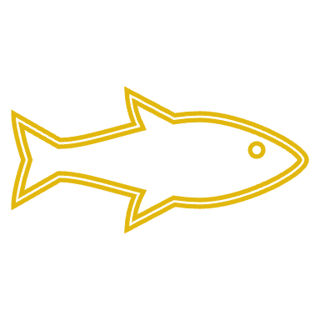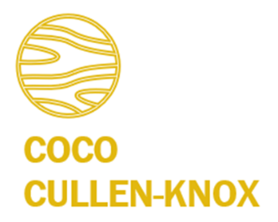

|  |  |  |  |
| --- | --- | --- | --- |
|  |  | | Coco Cullen-Knox, PhD  *Environmental sociologist*  0401 495 645  coco.cullenknox@gmail.com |
| ABOUT I'm excited about facilitating meaningful dialogue and decision-making processes across diverse groups to achieve innovative and holistic management of socio-environmental systems.  I believe that to create lasting positive change for people and the environment we need inclusive, transparent, accountable, reflexive and adaptable participatory processes.  With a unique blend of environmental and social science expertise, I’m most motivated when tackling complex socio-ecological challenges through collaborative, interdisciplinary research and management approaches.  My goal is to bridge gaps, find common ground, and develop solutions that balance environmental sustainability with social equity and cultural preservation. SKILLS Qualitative data collection, analysis and reporting  Stakeholder engagement and consultation  Environmental governance and policy advice  Science communication  Project management and team leadership | |  | |
|  | |

|  |  |  |  |  |  |
| --- | --- | --- | --- | --- | --- |
|  | | | | | |
|  |  | Education **PhD** 2021  (Accepted without changes)  Centre for Marine Sociology  *Media and environmental conflict over salmon aquaculture: Investigating the local and the transnational*  **Honours** in Marine Governance 2014  (First class)  Institute for Marine and Antarctic Studies  *The role of social license in the governance of common pool marine resources*  **Bachelor** of Applied Science 2011  The University of Queensland  Majors: Integrated Resource Management and Conservation Management  **Certificate in Engagement** 2022  International Association for Public Participation  **Coxswain 2NC** 2018  **Scientific and Master Diver** 2015 |  |  |

|  |  |  |  |  |
| --- | --- | --- | --- | --- |
|  | | | | |
|  |  | Employment history   Employer: **Sole Trader**  Period: **2018 - Current**  I provide independent research and consulting services in stakeholder engagement and consultation, governance and policy reviews and advice and qualitative data (e.g surveys, interviews, reports) collection, analysis and reporting.   * ThinkBank, Tasmanian Leaders (2018-2019) - Analysis of interviews and literature and reporting to support Tasmanian agribusiness and small business policy development. * <https://www.tasmanianleaders.org.au/wp-content/uploads/2019/12/Ideas-from-Thinkbank-2019-Our-Place-in-the-Sun.pdf> * https://www.tasmanianleaders.org.au/wp-content/uploads/2019/05/Thinkbank-2018-Small-Business_FinalReport.pdf * Seafood Futures (2024)- Synthesis of sector provided literature to develop Marine User Profiles and Regional What We Heard Reports. * The Nature Conservancy and NRM South (2024 - 2025) – White paper prepared for DCCEEW, bringing together expert input on Giant Kelp Forest conservation to inform the review of conservation advice under the EPBC Act. Followed by the design and delivery of a survey, workshop and associated report.   Employer: **University of Tasmania**  Position: **Researcher**  Period: **April 2015 - Current**  I have completed a range of research and project-based activities for The Institute for Social Change, Institute for Marine and Antarctic Studies and Centre for Marine Socioecology including but not limited to:   * Policy and governance advice for marine protected matters, integrated marine management, protected area management and social dimensions of managing the marine estate. For example, I co-managed a needs-based review providing operational and strategic planning and capacity-building recommendations for agencies with responsibilities under the New South Wales Marine Estate Management Strategy. * Lead and co-author on peer-reviewed academic papers in relation to marine governance, social license, science communication, and integrated marine management. * Qualitative data (e.g. surveys, interviews, media) collection, analysis and reporting that has informed science communication, governance and decision-making in the areas of climate change, fisheries management, marine estate management and environmental governance. See the Curious Climate project for an example (<https://curiousclimate.org.au>). * My PhD examined how environmental risks of common pool natural resources—particularly in salmon aquaculture—are negotiated through media, where science, community concerns, industry interests, and policy intersect. It explored the role of media, politics, and power in shaping environmental conflict, knowledge, and governance across local and global scales.   Employer: **Marine Solutions Tasmania**  Position: **Project Officer**  Period: **December 2014 – Current**  As part of the highly productive and supportive team at Marine Solutions, I provide expertise in marine science, project management and stakeholder engagement to deliver the following:   * Environmental impact assessments in accordance with relevant legislation. This has included leading a team conducting offshore environmental assessments to inform the decommissioning of oil and gas infrastructure. * Development and implementation of stakeholder engagement plans for government and industry clients. For example, I managed a feasibility assessment of artificial reefs and fish aggregation devices to meet a state government election commitment to enhance recreational fishing in Tasmania.   Employer: **Marine and Islands Parks Branch, Parks Australia**  Position: **Senior Project Officer - North Network**  Period: **April 2021 – November 2022**  I supported a small team in the implementation of the *North Marine Parks Network Management Plan 2018* by undertaking the following activities:   * Deliver the marine science program for the Northern Australian Marine Parks including project management and development of the *North Australian Marine Parks Science Plan.* * Support the delivery of the North Australian Marine Park Advisory Committee meetings including synthesising, implementing, and reporting on committee feedback. * Represent Parks Australia in internal and external stakeholder meetings and workshops. * Coordinate the review of the *North Foundation Implementation Plan* and the development of the *North Consolidation Implementation Plan.*   Employer: **World Wide Fund for Nature**  Position: **Assistant Project Coordinator - Seafood and Fisheries Emerging Technologies Conference**  Period: **February 2018 – April 2019**  I co-delivered the Seafood and Fisheries Emerging Technologies Conference held in Bangkok, Thailand attended by 250 participants from around the world. I produced the related report which can be found at  <https://docs.wixstatic.com/ugd/a17859_8c02db62167d47d9a1555d4762720ecb.pdf>  Employer: **Various environmental consultancies and research organisations**  Position: **Environmental Scientist**  Period: **2011 to 2013**  In my early career, I worked for consultancies and research organisations, ranging from those that operate on the global scale (including developing and implementing a research project on a remote island in Fiji) to smaller family-owned and operated consultancies. |  |  |

|  |  |  |  |
| --- | --- | --- | --- |
| A black sand beach and deep blue waters | | | |
|  |  |  |  |  |

